**Context Diagram (DFD level 0)**

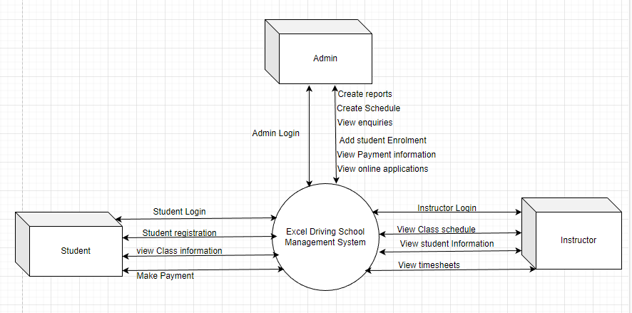

**Fig: Context Diagram of Excel Driving School Management System**